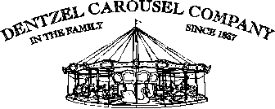
William H. Dentzel, Owner
843 53rd Street
Port Townsend WA 98368

APPRAISAL

Date: August 24, 2012

Requested by: Mona Biddlecome

Piece: Gustav Dentzel Goat

Dimensions: 62” x 63” (approximate)

Description: Very rare galloping goat; one of only four known pieces in this position. Philadelphia style; built circa 1900. Restored in 1970’s by Marianne Stevens.

Estimated Value: $38,000. - $48,000.

